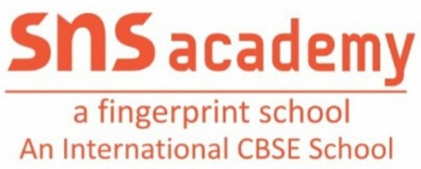
ANNUAL PLAN(2022-2023)
Grade: LKG Subject: EVS
MONTH | UNIT/TOPIC
JUNE | - MYSELF  - RAMZAN
JULY | - MAJOR BODY PARTS
AUGUST | - PERSONAL HYGIENE  - FAMILY
SEPTEMBER | - LET US KNOW EACH OTHER  - NAVRATRI
OCTOBER | - ROOMS IN THE SCHOOL  - COMMUNITY HELPERS  - DIWALI
NOVEMBER | - PLANTS, FRUITS AND VEGETABLES
DECEMBER | - FLOWERS  - CHRISTMAS
JANUARY | - ANIMALS  - DOMESTIC AND WILD ANIMALS
FEBRUARY | - TRANSPORT

Teacher Incharge: S.SWARNALAKSHMI

